

**Garlic Rasam**

Garlic Rasam, known as "Poondu Rasam" in Tamil, is a traditional South Indian soup celebrated for its tangy flavor and potential health benefits, including liver support. Here's a simple recipe to prepare this comforting dish:

**Ingredients:**

* 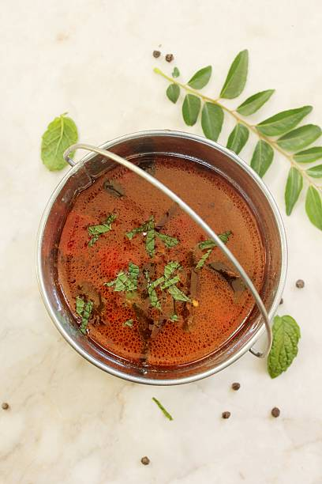1 tablespoon tamarind pulp
* **1 cup water**
* **1 tablespoon ghee (clarified butter) or oil**
* **1 teaspoon mustard seeds**
* **1 teaspoon cumin seeds**
* 2 dried red chilies
* 10 cloves garlic, crushed
* 1 medium tomato, chopped
* 1/2 teaspoon turmeric powder
* 1 teaspoon black pepper powder
* Salt to taste
* 2 cups water
* Fresh coriander leaves, chopped (for garnish)

**Instructions:**

1. **Prepare Tamarind Water:**
   * In a bowl, mix tamarind pulp with 1 cup of water. Let it sit for 10 minutes, then strain to extract tamarind water.
2. **Sauté Aromatics:**
   * Heat ghee or oil in a pan over medium heat. Add mustard seeds; when they splutter, add cumin seeds and dried red chilies.
   * Add crushed garlic and sauté until golden brown.
3. **Cook Tomatoes and Spices:**
   * Add chopped tomatoes to the pan and cook until soft.
   * Stir in turmeric powder, black pepper powder, and salt.
4. **Combine with Tamarind Water:**
   * Pour the tamarind water into the pan. Bring the mixture to a boil.
5. **Add Additional Water:**
   * Add 2 cups of water and let it simmer for 5-10 minutes.
6. **Garnish and Serve:**
   * Garnish with chopped coriander leaves. Serve hot.

This Garlic Rasam is not only flavorful but also incorporates ingredients like garlic and tamarind, which are known for their potential health benefits, including supporting liver function.